Name:______________________________ Date:________________
THIS HOMEWORK IS DUE BY: _______________________
Weekly Homework 9 Mrs. Zunich

- Convert the following values from standard form to scientific notation.
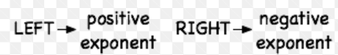

a) 6,730,000 = ________________________________________________

b) 0.000067 = ________________________________________________

- Convert the following values from scientific notation to standard form.
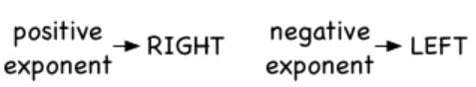
- $3.14 × {10}^{-7}$= _____________________________________________

- $6.809 ×{10}^{5}$= ______________________________________________

- Identify the legs, a and b, and the hypotenuse, c, of the right triangles below.
13 feet
A=________
B=________
C=_________
5 feet

12 feet

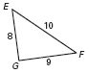
A=________
B=________
C=_________
- Find the missing side of the right triangle. Make sure to use the Pythagorean Theorem. $a^{2}+b^{2}=c^{2}$
- 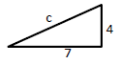 b) 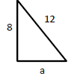

- Determine if each triangle is a right triangle.

- 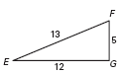  a=________  b=________  c=_________ | a=________  b=________  c=_________

- REFLECTION: Circle the picture that best describes how YOU feel about changing multiplying values in scientific notation.

