Name:_________________________ Date:__________________
My CEUA 3A is on _____________________________.
CEUA 3A STUDY GUIDE Mrs. Zunich

Directions: Below is a guide to study from for your CEUA 3A. Make sure you have your answers to the problems check.
** If you have any questions about the problems below. PLEASE stay with Mrs. Zunich.

- Pythagorean Theorem

_________+___________=________
Solve for finding the missing leg. | Solve for finding the missing hypotenuse.
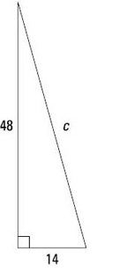

- Write algebraic expressions for the examples below. REMEMBER TO USE THE CUBES STRATEGY TO ANNOTATE!!

- Nine less than twice a number. _____________________________
- 17 and the sum of four times a number. ________________________
- The difference between 39 and twice a number. ___________________

- Fill in the multi-step equation steps and solve the multi-step equations below.
Steps for Solving Multi-step Equations
- ____________________ ( ).
- _____________ like terms on the same side.
- _____________ variable to one side of the equation.
- _____________ constant to the other side.
- Multiply or Divide.

- $-2=3k+4$ c. $5k-2=2(4k+2)$

- $5+10\left(x+2\right)=35$ d. $5k-2=8k+4$

- Mrs. Zunich solved the equation, $b+3+2 \left(b+3\right)=57.$ Her work is shown below. Is she correct or incorrect? Explain your answer.
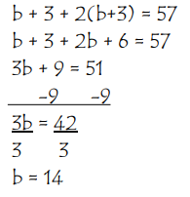
________________________________________________________________________________________________________________________________________________________________________________________________________________________________________________________________________________________________________________________________________________________________________

- When I verify an equation, I plug my solution into the given equation. For the examples below. SOLVE AND VERIFY the equations.
Steps for verifying equations
Step 1: Rewrite ______________________ equation.

Step 2: _________ in your _____________into the variable place.

Step 3: Follow _____________________ (DO THE ______________!)

Step 4: Make sure each ______________ of the ______________is ________________.

$a. -2=3k+4$ c. $5k-2=2(4k+2)$

$b. 5+10\left(x+2\right)=35$ d. $5k-2=8k+4$

